
MATHEMATICS DEPARTMENT
Year 12 MATHEMATICS SPECIALIST
DATE: 4th December 2015 Name__________________________
Reading Time: 3 minutes
SECTION ONE: CALCULATOR FREE
TOTAL: 27 marks
EQUIPMENT: Pens, pencils, pencil sharpener, highlighter, eraser, ruler, SCSA formula sheet.
WORKING TIME: 25 minutes (maximum)
SECTION TWO: CALCULATOR ASSUMED
TOTAL: 25 marks
EQUIPMENT: Pens, pencils, pencil sharpener, highlighter, eraser, ruler, drawing instruments, templates, up to 3 Calculators,
1 A4 page of notes (one side only), SCSA formula sheet.
WORKING TIME: 20 minutes (minimum)
SECTION 1  Question | Marks available | Marks awarded | SECTION 2  Question | Marks available | Marks awarded
1 | 6 |  | 5 | 7
2 | 6 |  | 6 | 4
3 | 10 |  | 7 | 7
4 | 5 |  | 8 | 7
Total | 27 |  |  | 25

Section One: Calculator-free [27 marks]

This section has Four (4) questions. Answer all questions. Write your answers in the spaces provided

Question 1 [6 marks]

Simplify each of the following expressions, writing your answer in exact polar form.
(a)
Applies de Moivre’s theorem
change to polar form

[2]
(b)
Applies de Moivre’s theorem
Simplifies answer

[2]
(c)
Applys de Moivre’s theorem
Able to manipulate index
[2]

Question 2 [6 marks]

(a) (i) Find the quotient and the remainder for , hence rewrite in the form [3]

Divides to find H(z)
Finds the remainder is 2z
rewrites the expression correctly

(ii) Hence, solve [3]

solves for the other two solutions
solves for z = 1

Question 3 [10 marks]
Given the graph of is given as follows;
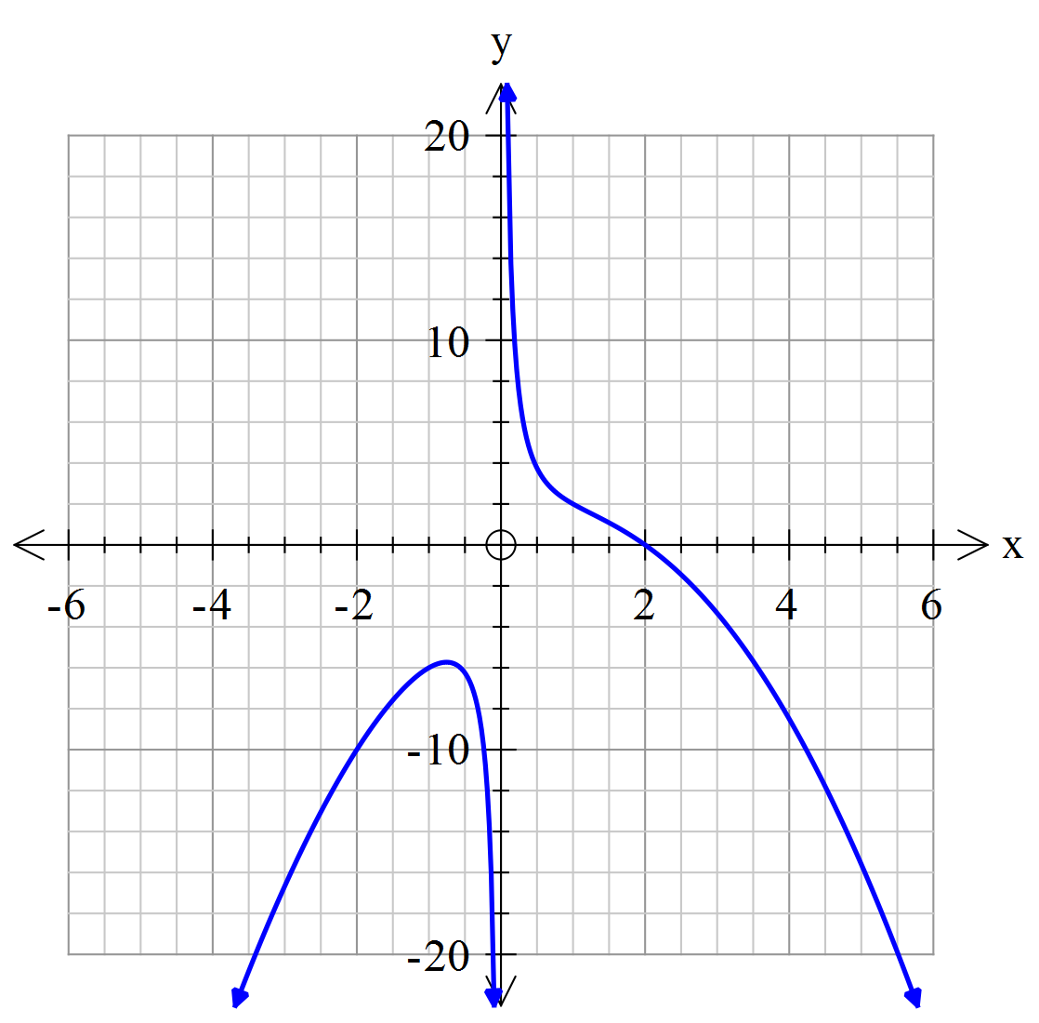
Sketch the graph of
(a) (i)
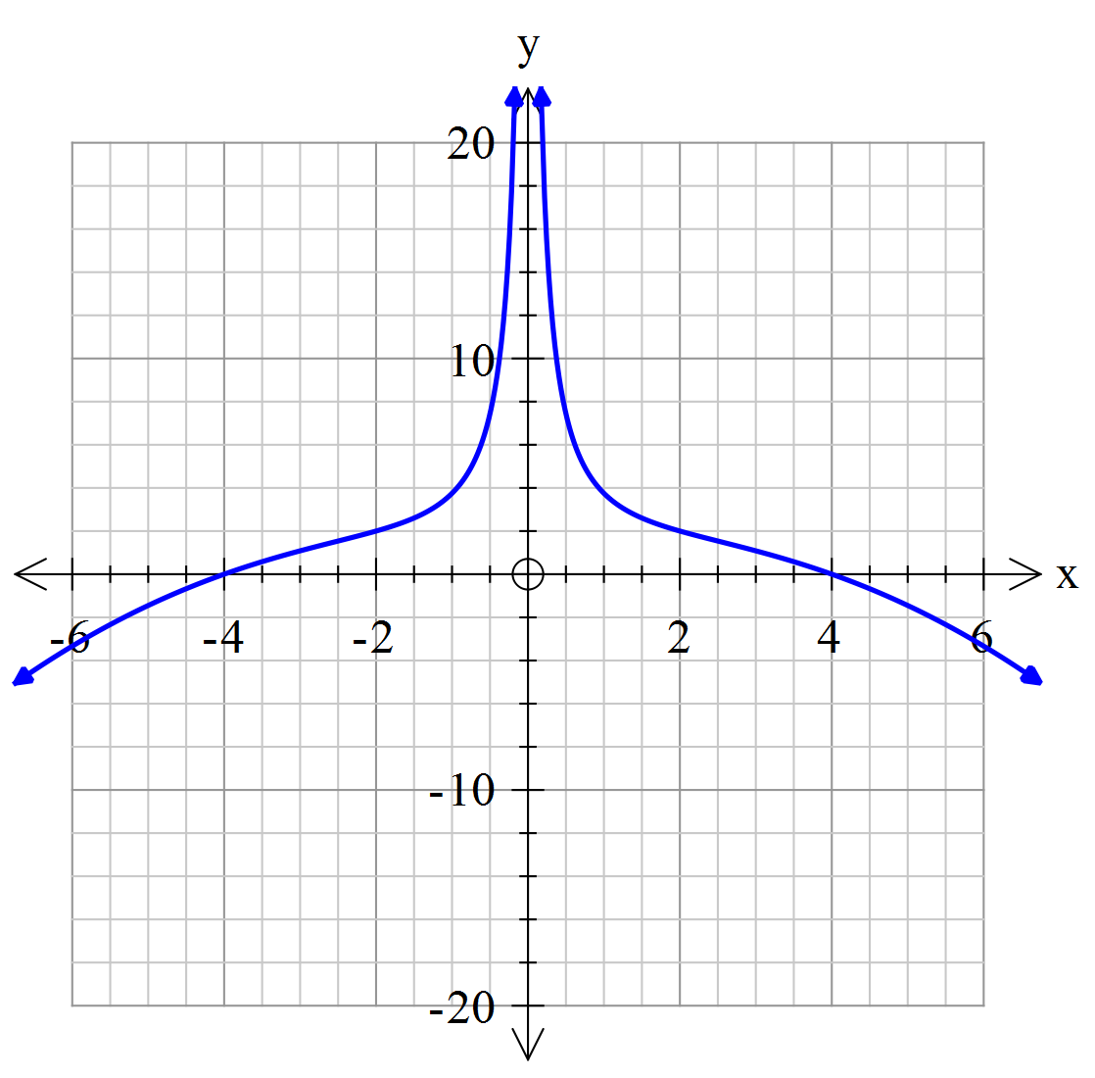
removes the graph x<0
mirrors the graph x>0 over the y-axis
dilates the graph by a scale factor of 2 along the x-axis

[3]

(ii) Sketch the graph of . [3]
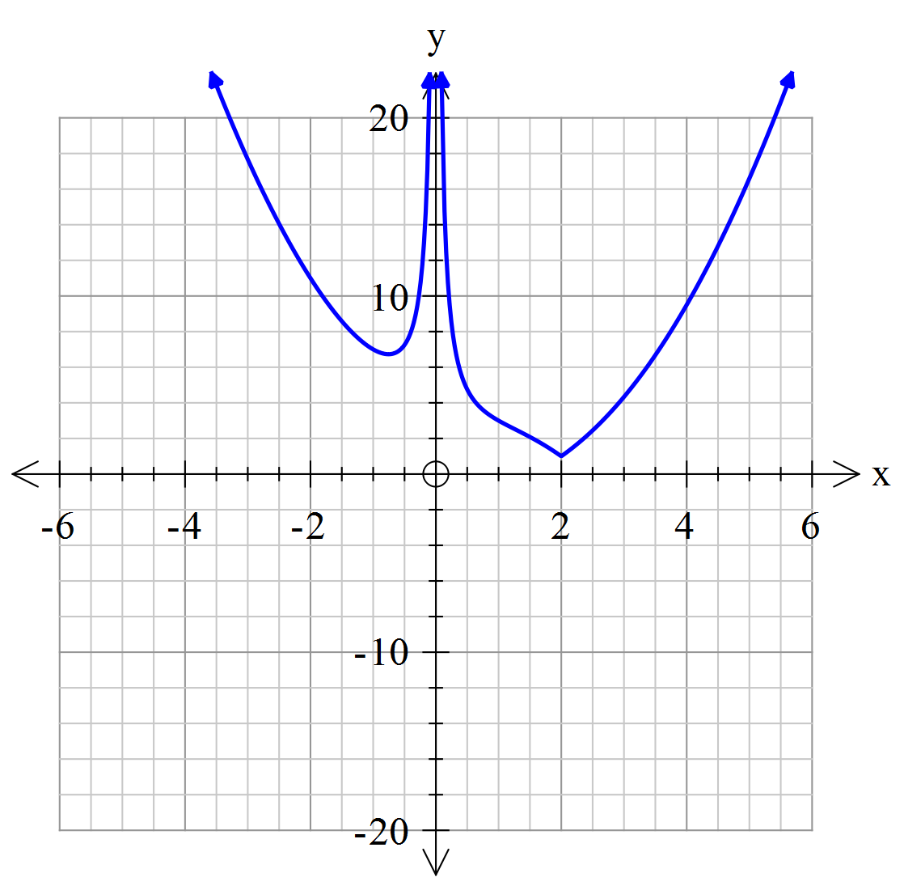
reflects the part of the graph y<0 over the x-axis for x>0
reflects the part of the graph y<0 over the x-axis for x<0
translates the graph 1 unit up

(b) Given that and , find the domain and range of the composite function [4]
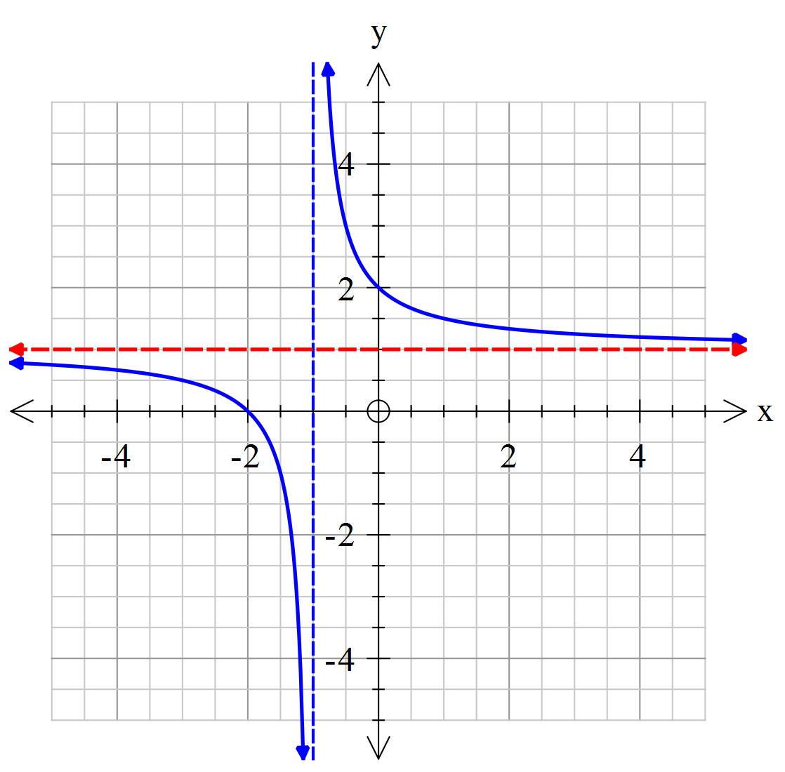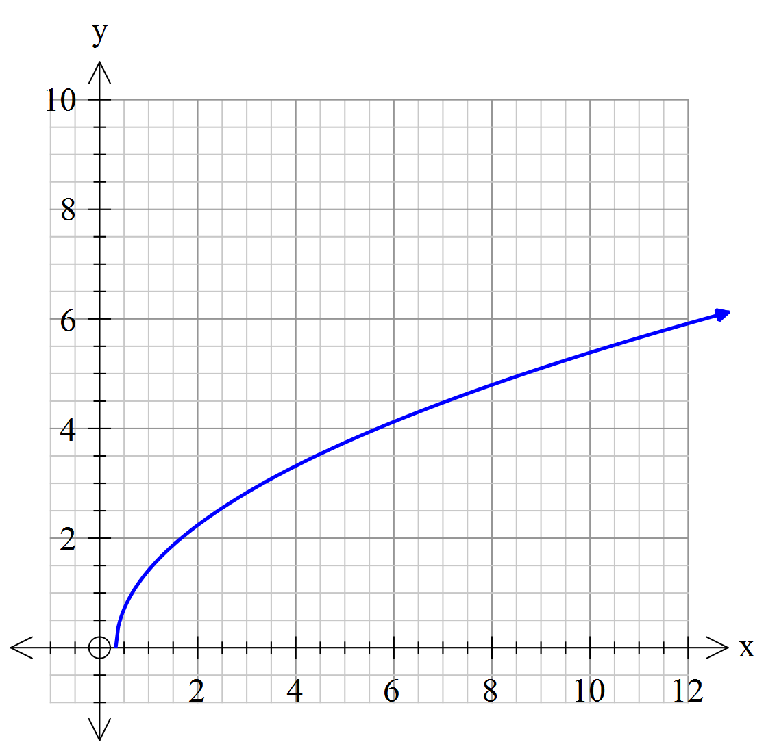
Domain Range

Both domain restrictions (1 mark each)
Both range restrictions (1 mark each)

Question 4 [5 marks]

(a) On an Argand diagram sketch the loci of points and that satisfy the following condition;

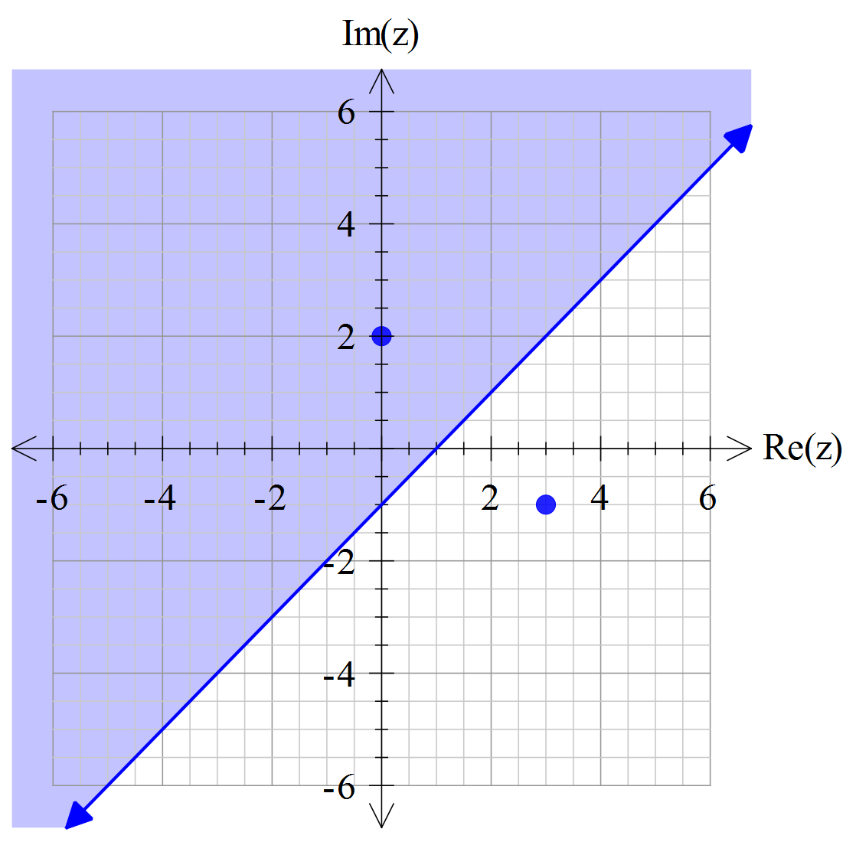 [3]
Graphs two points
Draws a line through the midpoint, perpendicular
Shades above the line

(b) Give the equation of the locus in Cartesian form.

Sets up Cartesian equation simplified
Simplifies with correct inequality

[2]

NAME:_______________________________________
Section Two: Calculator-assumed [25 marks]
This section has four (4) questions. Answer all questions. Write your answers in the spaces provided

Question 5 [7 marks]

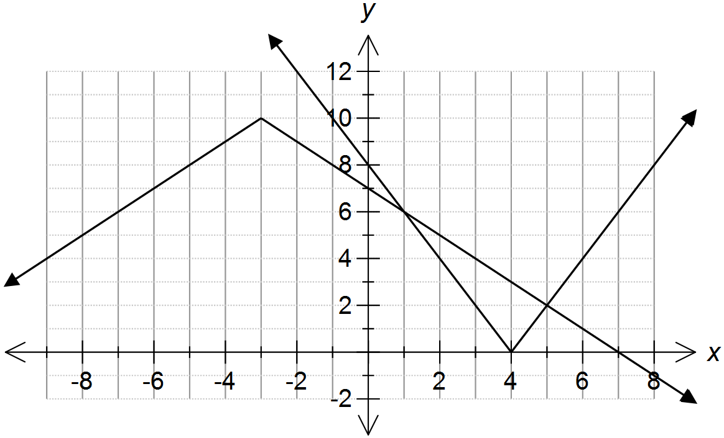

(a) Use the diagram above to solve for x in the following.

(i)
[1]
Both x values given

(ii)
Correct x –values
Correct domain

[2]

(b) Solve the following algebraically [4]
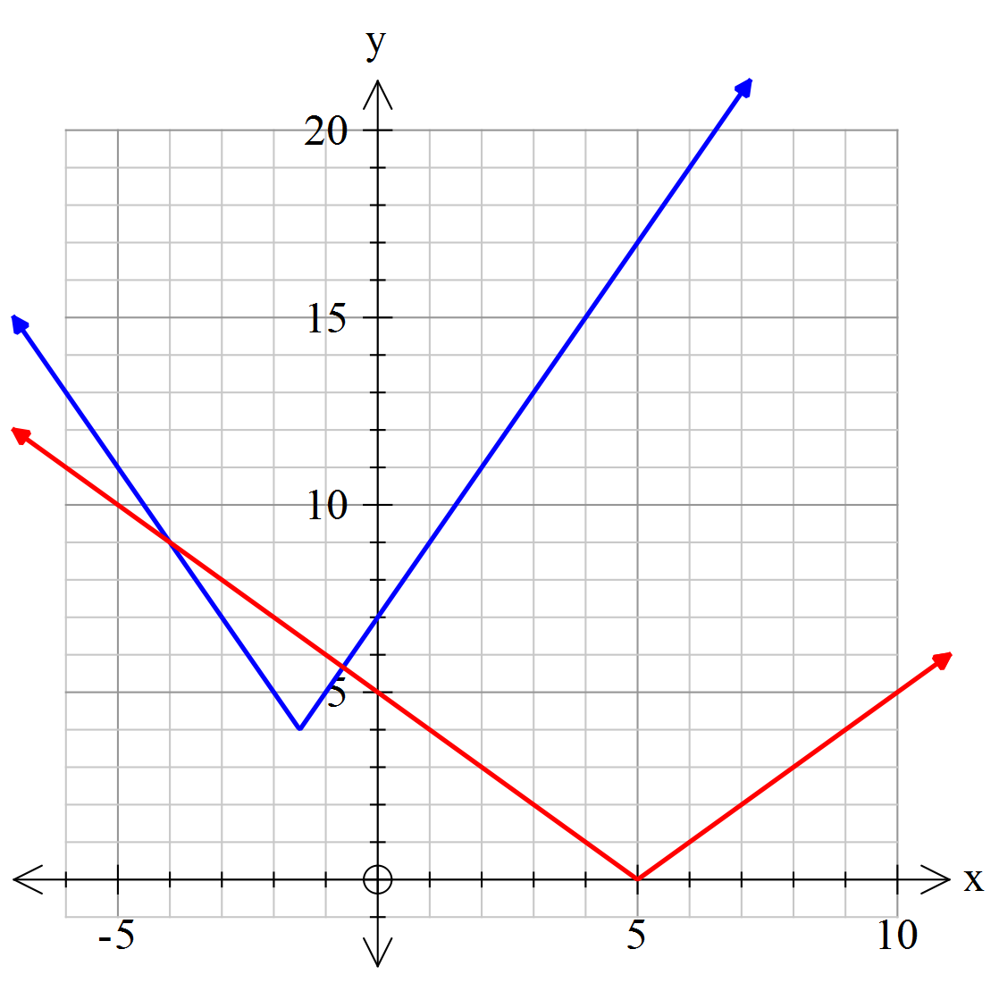
Draws a graph and identifies the critical points of x=-1.5 and x=5
Finds the correct linear equations of each relevant function
Solves for the 2 intersections
Writes the inequality correctly

Question 6 [4 marks]

Given the position of z and w on the Argand diagram below. Label the points A, B, C and D using the following options.

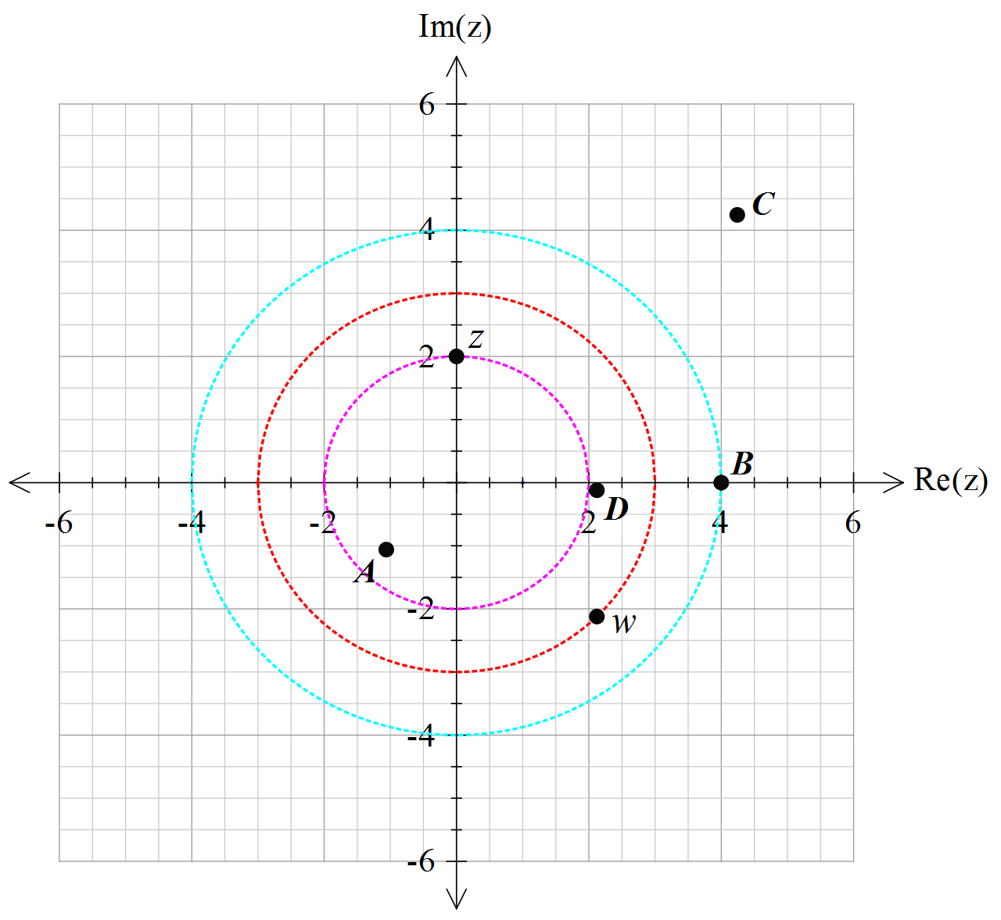

A [1]

B [1]
1 mark each correct answer

C [1]

D [1]

Question 7 [7 marks]

(a) Represent on the Argand diagram provided below, the loci of points, that satisfy the following conditions;
, and
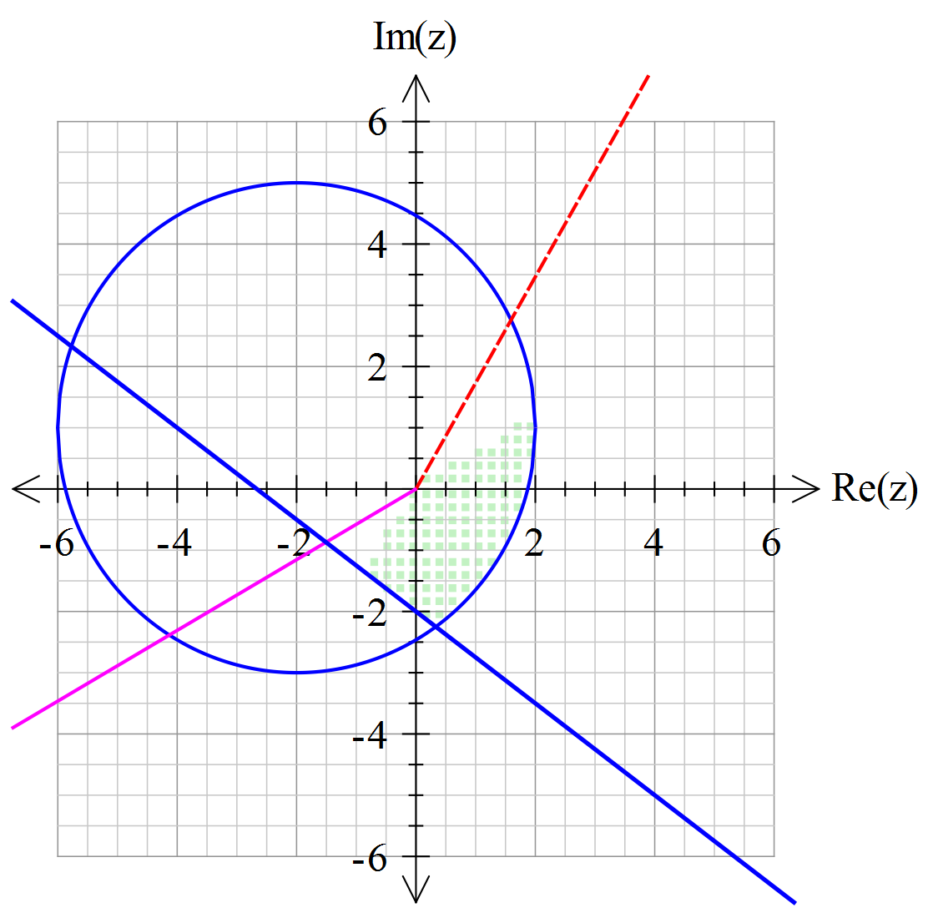
Circle drawn correctly
Arg drawn correctly
Line drawn correctly
Shades correctly

[4]
(b) Given that state the minimum and maximum value of .

Finds radius
States min correctly
States max correctly

[3]

Question 8 [7 marks]

- Using your CAS calculator (or otherwise) find all the solutions to in exact polar form, where and . [4]

Changes to polar form
applies De Moivre’s theorem and gives first solution
Identifies they need to add 2PI/5
Gives other 3 solutions

- Draw the solutions from (a) on the complex plane below. Show all major features.
[3]
Correct placement and magnitude of first point z
All other points magnitude of 4
Other solutions are distributed evenly 2PI/5 angle apart

